Community Infrastructure Levy (CIL) Non-Parish Funding
Local Infrastructure Schedule, Project Assessment and Proposed Funding Allocations

February 2024
Contents
1. | Background | 3
2. | CIL Non Parish Neighbourhood Portion Receipts | 7
3. | Local Infrastructure Schedule | 10
4. | Project Assessments | 12
5. | Recommendations | 25
6. | Further Projects | 26
7. | Consultations | 27
8. | Contact | 28

- Background

  - The Planning Act 2008 introduced the Community Infrastructure Levy (“CIL”) as a tool for local authorities in England and Wales to help deliver infrastructure to support the development of their area. CIL came into force on 6 April 2010 through the Community Infrastructure Levy Regulations 2010.

  - Gedling Borough Council introduced CIL in October 2015. Following an independent examination in March 2015 and approval at full council on 15 July that year, the Gedling Borough Council Community Infrastructure Levy Charging Schedule was adopted on the 16th October 2015. Gedling Borough Council is the charging authority for the borough of Gedling.

  - Regulation 59A of the Community Infrastructure Levy Regulations 2010 (as amended) (“the 2010 Regulations”) places a duty on charging authorities to allocate at least 15% (up to a cap of £100 per existing council tax dwelling) of CIL receipts to spend on priorities that should be agreed with the local community in areas where development is taking place. This is known as the neighbourhood portion.

  - Where the chargeable development takes place in an area where there is no parish council, the charging authority retains the levy receipts but must spend the neighbourhood portion on, or to support, infrastructure in the area where the chargeable development takes places. This should be done in consultation with the local neighbourhood.

  - The extent of the parishes however does not cover the majority of the urban area of Gedling Borough (with the exception of Colwick). This creates a gap in the coverage for the neighbourhood portion in the Borough where there are no parishes or town councils to oversee its expenditure.

  - The non-parish areas of Gedling Borough as shown in Figure 1 cover the following Wards:

- Calverton (part) | - Carlton
- Carlton Hill | - Cavendish
- Colwick (part) | - Coppice
- Daybrook | - Ernehale
- Gedling | - Netherfield
- Phoenix | - Plains
- Porchester | - Redhill
- Trent Valley (part) | - Woodthorpe
Figure 1. The Non-Parish Area of Gedling Borough
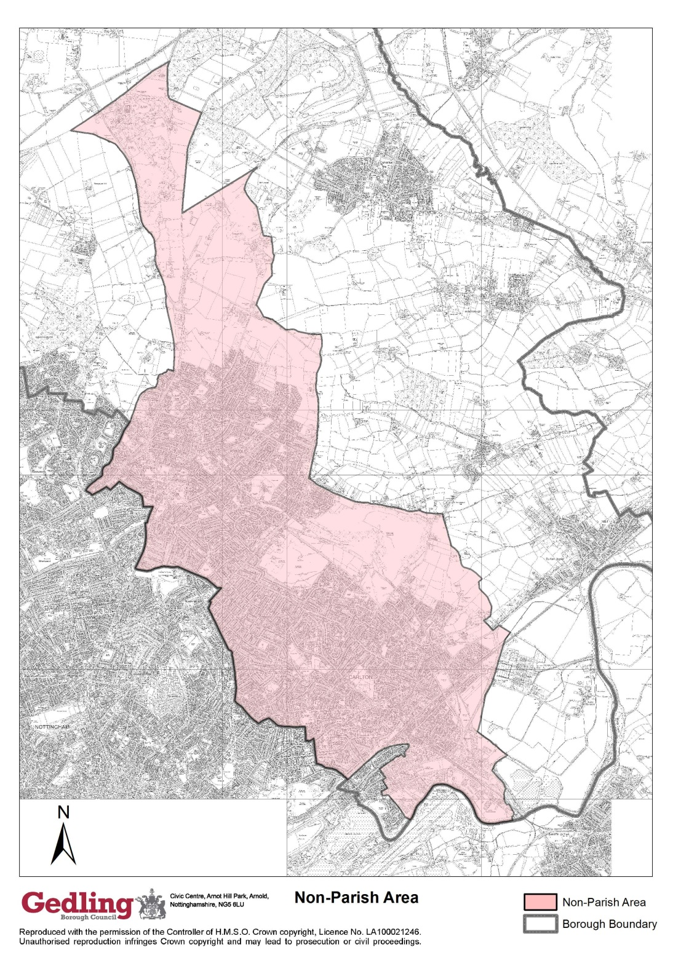

  - Regulation 59F of the 2010 Regulations states that where no parish or town council exists the charging authority may use the neighbourhood portion of CIL, or cause it to be used, to support the development of the relevant area by funding:-
- The provision, improvement, replacement, operation or maintenance of infrastructure; or
- Anything else that is concerned with addressing the demands that development places on an area.
  - The ‘relevant area’ is defined by Regulation 59F (1)(4) as that part of the charging authorities area that is not within the area of a parish or town council.

  - The Community Infrastructure Levy Guidance (“the Guidance”) published on 12 June 2014 makes it clear that the charging authority should engage with the local communities where the development has taken place and agree with them how best to spend the neighbourhood funding. The Guidance also emphasises the importance of the neighbourhood portion being used to deliver the infrastructure needs of the area in which the chargeable development has taken place.

  - The Guidance states that “charging authorities should set out clearly and transparently their approach to engaging with neighbourhoods”.

  - A guidance note dated March 2015 prepared by the Council titled ‘CIL and the Neighbourhood Portion in Non-Parish Areas detailed how the Council would:-

- Consult with the local community over how the neighbourhood portion of CIL receipts will be spent in non-parish areas.
- Decide which infrastructure projects will benefit from funding from the neighbourhood portion of CIL receipts in non-parish areas.

  - The Guidance Note creates a process that invites the local community, groups and organisations to identify and have their say on appropriate projects for expenditure of the neighbourhood portion of CIL receipts. Groups, organisations and individuals can nominate potential infrastructure projects throughout the year using our online form; nominations can be submitted throughout the year.

  - This Assessment Document has been prepared and is structured to present the following information in accordance with the Councils CIL Guidance Note:
- CIL Receipts (What Non-Parish Neighbourhood Funding has been collected)
- Local Infrastructure Schedule (A List of potential infrastructure projects that have been submitted for consideration)
- Project Assessment (An assessment of all projects submitted detailing their suitability for funding)
- Project Recommendations (Recommendation of which infrastructure projects (if any) should be funded via the CIL Neighbourhood Funding)
- Further Projects (Opportunity for projects to submitted for consideration next year)
- Information on how the public consultation will be undertaken.

- CIL Non-Parish Neighbourhood Portion Receipts

  - In order to make appropriate awards of CIL Neighbourhood Funding in Non-Parish areas of the Borough there is a need to accurately report on Non-Parish CIL Receipts which are currently held by Gedling Borough Council.

  - 2017/2018 was the first financial year in which CIL Neighbourhood Funding in the non-parish area of Gedling was awarded. Since this time, a total of £317,260 has been awarded to suitable infrastructure projects within the Non Parish Area of Gedling.

- £3,500 award to Lighting at Cinderpath scheme in Netherfield,
- £100,000 award to Car Park Extension at Gedling Country Park,
- £40,000 award to Changing Room Facilities at Lambley Lane Recreation Ground,
- £50,000 award to Green Lung Corridor at Mapperley / Gedling,
- £43,000 award to Arnold Marketplace development in Arnold Town Centre,
- £25,000 award to Footpath Extension at Willow Park, and
- £55,760 award to Internal works and alterations at Netherfield Forum Children, Young People and Families Hub.

  - At the end of the last financial year 2022/23 (31st March 2023) the amount of unallocated CIL Receipts for the Non-Parish Neighbourhood proportion stood at £276,411.

  - Since this time, additional CIL receipts have been collected throughout 2023/24 and, as of the 31st December 2023, the amount available for expenditure through the Non-Parish Neighbourhood portion stands at £578,815.

  - It should also be noted that additional CIL receipts may be collected from other CIL liable planning permissions further increasing the Non-Parish Neighbourhood portion before a final decision on which projects, if any, are successful.

  - The table below sets out the portion of CIL Receipts for the Non-Parish Neighbourhood Funding which have been collected across the Non-Parish area to date.

Table 1. Breakdown of total CIL Non-Parish Portion Receipts collected by Ward as of 31st December 2023 (to the nearest £)
Area (Ward) | Collected
Coppice | £129,672
Daybrook | £4,503
Ernehale | £9,980
Gedling | £610,690
Mapperley Plains | £2,703
Netherfield | £7,260
Phoenix | £952
Porchester | £15,643
Trent Valley | £110,160
Woodthorpe | £4,512
Total Non-Parish Collection | £896,075
2017/2018 Allocations | £3,500
2018/2019 Allocations | £140,000
2020/2021 Allocations | £93,000
2021/2022 Allocations | £80,760
Remaining Non-Parish Neighbourhood Holdings | £578,815

  - In accordance with the produced guidance note, the Council will prioritise expenditure of the neighbourhood portion of CIL receipts in non-parish areas as set out in the following table:
Table 2: Approach to Expenditure of CIL Neighbourhood Portion in Non-Parish Areas
Priority | Type of Infrastructure Project and Location
1 | Infrastructure projects (including Infrastructure Funding Statement projects) in the ward where the chargeable development has occurred.
2 | Infrastructure projects (including Infrastructure Funding Statement projects) in the non-parish are of Gedling which meet or support the development needs of the area where the chargeable development has occurred.
3 | Pool the neighbourhood portion of the CIL receipt for the following year where no suitable infrastructure projects 1 and 2 above have been identified.

- Local Infrastructure Schedule

  - In order to identify appropriate infrastructure projects for part funding/funding via CIL Non-Parish Neighbourhood Funding a nomination process was opened and continues to be open.

  - A list of nominated projects has been created that forms a Local Infrastructure Schedule for the non-parish area of Gedling. A summarised list of nominated projects is highlighted below in Table 3.

Table 3: Local Infrastructure Schedule (Summary Table)
Project | Nominator/Proposer | CIL Monies Required
Cinder Path Extension (Netherfield) | Gedling Borough Council (Economic Growth & Regeneration) | £200,000
Gedling Youth & Communuty Hub Regeneration Project at Former Railway Station (Gedling) | Gedling Youth & Community Hub | £75,000
Lambley Village Cricket Pavillion (Gedling) | Lambley Village Cricket Club | £75,000
MAS Community Sports Development (Gedling) | The MAS Community | £540,000
1st Gedling Scouts Group HQ Refurbishment | 1st Gedling Scouts Group | £60,000

All projects submitted have been formally assessed and a recommendation has been made as to each project’s current suitability for funding. The assessment is based upon information submitted as part of the nomination process. The focus of projects should be that they accord with Regulation 59F of the 2010 Regulations. Other determining factors which shall be considered included:-
- How does the project meet a need created by new development?
- Timeframe for delivery?
- Is match funding available?
- How infrastructure project will be maintained once completed?

- Project Assessments

  - An assessment of each submitted project has been prepared, each assessment must be accompanied with the following information;-
- Reference Number;
- Description of the project;
- Location;
- Lead agency;
- How it meets the need created by new development,;
- Whether CIL Funding is required to deliver the projects;
- Total cost of projects;
- How much CIL monies are required;
- Is match funding available;
- Timeframe for delivery;
- How the project will be maintained once completed; and
- An assessment of the project suitability for CIL Neighbourhood Funding.

  - A total of five projects are on the Local Infrastructure Schedule this year. LIS1 and LIS2 were retained on the schedule from last year’s consideration whilst three new projects were submitted this year. The initial assessment for each project and whether they are suitable for CIL Non-parish Neighbourhood Funding can be found below.

Project Assessments
Project Reference:  LIS1 | Project Name:  Cinder Path Extension (Netherfield)
Project Description:
This proposal seeks to extend the existing section of the Cinder Path to incorporate a section of the disused railway line, which runs between Ashwell Street to Manvers Street, to its junction with the old level crossing on Victoria Road.

An initial site investigation has been carried out to identify any constrains and inform the development of the consultation design options. A public consultation has been undertaken and the results from the consultation have determined that the preferred option for the design of the project is Design 1.

The CIL monies would be utilised to cover the costs of refurbishing the existing route including, ground works, re-surfacing, the planting of new trees and vegetation to improve biodiversity, lighting columns, fencing and seating.

Location:
Cinder Path at Manvers Stree and Victoria Road, Netherfield

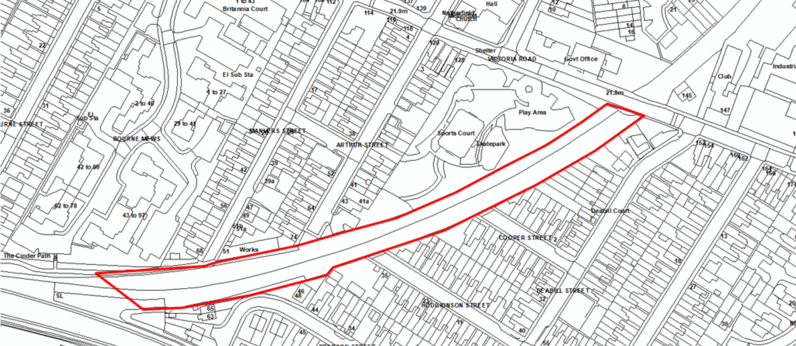

Lead Agency:
Gedling Borough Council – Economic Growth and Regeneration
How does the project meet a need created by new development:
The disused railway line lies entirely within the built up areas of Gedling and Netherfield on the eastern edge of the Greater Nottingham conurbation. The former railway line ends at Gedling Country Park which, as well as being a popular green space, also acts as a gateway into the countryside and beyond. The route bisects residential areas and runs adjacent to established industrial and employment land use. In addition, the former railway line runs adjacent to two significant mixed use residential and employment development sites at Teal Close, Teal Park and on the former Gedling Colliery yard site (also known as Chase farm Development site). The former railway line also inter links with 12 green open spaces allotments and lies adjacent or very near to 2 primary and one secondary school.

The creation of the linear green park/cycleway would:
- Create a valuable additional green space
- As the line is extended it will connect 6 existing recreation areas and parks creating a green space network, between Gedling Country Park and Netherfield.
- The route will provide sustainable transport links between housing, employment and recreation routes.
- The linear route will be safeguarded for possible future tram development.

The benefits will therefore include:
- Opportunity for free and healthy recreation
- Enhanced biodiversity
- Access to natural green space for residents and visitors
- Opportunity for community engagement in creative arts and environmental projects
- Improved image and potentially increased business for Netherfield town centre

Total cost of project:
£598,000
How much CIL Neighbourhood Funding is required:
£200,000
Is match funding available:
Potential opportunity to bid to Severn Trent Water Foundations Trust for £250,000 to support delievry of the project.
Timeframe for delivery of project:
N/A
How will the project be maintained once completed:
Gedling Borough Council – Parks and Street Care Maintenance Programme.
Assessment of project:
This nominated project would be compliant with Regulation 59F of the 2010 Regulations as it is located in a ward which has contributed CIL Receipts from local development.

The project would redevelop a disused path creating improved recreational facilities within a Ward where there is a need for useable green spaces which can be used for both walking and cycling, improving the health of local residents. The proposal will link two existing green spaces, namely the previously redeveloped part of the Cinder path and Jackie Bells Field, and improve biodiversity and wildlife in the locality through the planting and management suitable trees and plants.

Whilst it is considered that the project would be a good fit for the Non-Parish Neighbourhood Funding Awards, Gedling Borough Council are not currently looking to progress this project. The proposal is still in the early stages of development and it would not therefore be appropriate to recommend this project for CIL Non-Parish Neighbourhood funding at this stage.

Taking the above into consideration, it is my recommendation that the project LIS1 should not be awarded Non-Parish Neighbourhood Funding at this time. I would however recommend that the project is retained on the Local Infrastructure Schedule.

Recommendation: No allocation for CIL Non-Parish Neighbourhood Funding at this time. Retain on Local Infrastructure Schedule.

Project Reference:  LIS2 | Project Name:  Gedling Youth & Communuty Hub Regeneration Project
Project Description:
The Gedling Youth & Community Hub is a registered charity (522200) previously known as Gedling & District Youth Club. The charity is seeking CIL awards to undertake a regeneration project to carry out refurbishments to the former railway station off Shearing Hill, Gedling. The aims of the Charity are to restore & enhance (partly already completed) the former Victorian railway station (1876) embracing the building’s rich history & heritage. It sits alongside the proposed Gedling Heritage Way. The project will create a vibrant young persons & community facility. It will improve the health & wellbeing of local people by developing a stronger & more resilient community.

The proposal would see substantial works be undertaken, including new kitchen facilities, a new entrance hall, restoration of sash Windows, re-tile & securing of loose roof tiles and new guttering. There is also a gym attached to the old station is due to be demolished as part of the project.

The future plans can be viewed at the community hub or on the website. www.gedlingyouth.co.uk

The Gedling Youth & Community Hub would focus the bid for £75k on those items that will help unlock the Heritage Fund application of circa £250k, whilst also delivering a package of work that enables the building to become functional and accessible again (as it is currently constrained to use as a construction skills training facility, due to water ingress).

Specifically these works would include:
- demolition of the unsafe structure of the gym extension
- provision of scaffolding to the single storey section of the building
- repairs to the roof, including re-instatement of slates to the single storey section.

Location:
Gedling Youth Club Youth Centre, 13 Shearing Hill, Gedling, Nottinghamshire, NG4 3GY
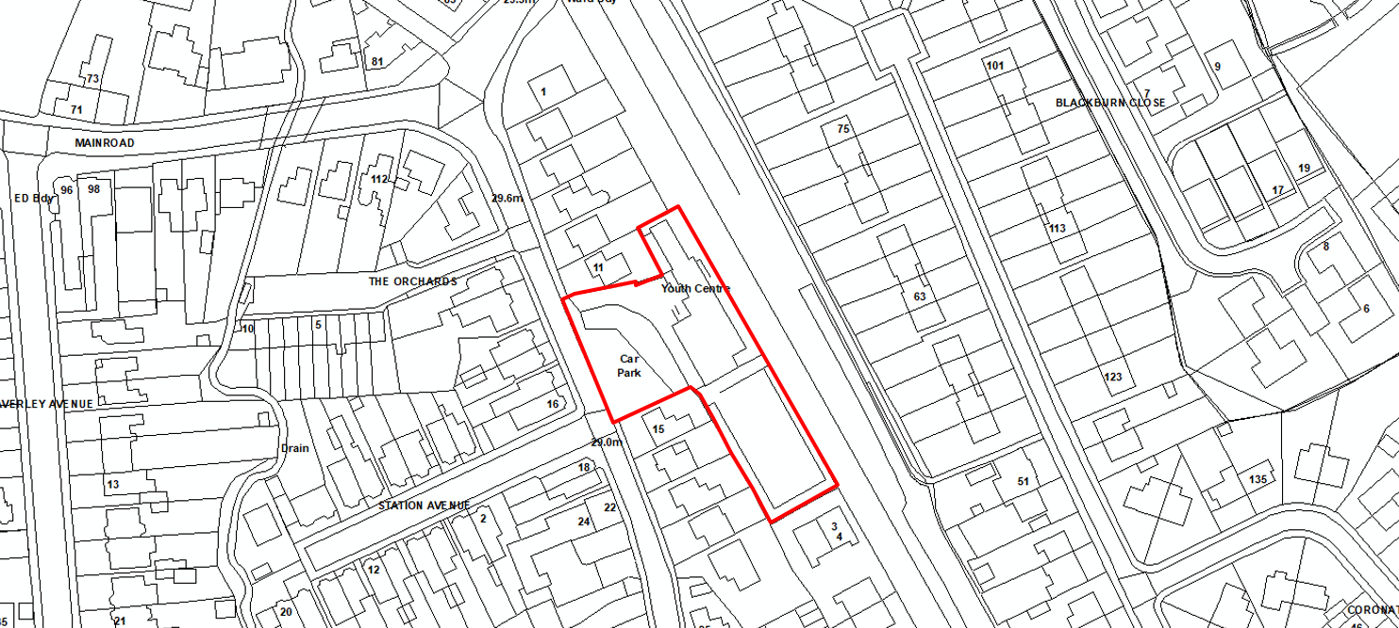

Lead Agency:
Gedling Youth & Community Hub
How does the project meet a need created by new development:
The commencement of major housing developments at Chase Farm in Gedling, Rivendell in Netherfield and other sites within the locality, means that the area needs a community hub that all local residents can access for community events or simply to meet and greet for a chat.

The proposed Heritage Way runs past the former Gedling railway station, now the Gedling Youth & Community Hub. This cycle/walkway green lung is much needed in the area of benefit for the wellbeing and improvement of mental health for residents. There are other significant benefits to be gained, particularly from decongestion on the local highway network and increased physical activity amongst existing and thousands of new residents.

The Gedling Youth & Community Hub will be a stopping off point along the Heritage Way for walkers and cyclists. The history and heritage of the mining and railway in our area will be celebrated in the cafe and community rooms. The footfall from the Mott MacDonald report in 2016 approximated 275,000 walkers and 155,000 cycle trips per annum.
Total cost of project:
£250,000
How much CIL Neighbourhood Funding is required:
£75,000
Is match funding available:
Potential match funding through the National Heritage Lottery Fund. A bid is currently being drafted and is expected to be submitted to the NHLF in early 2024 for consideration.
Timeframe for delivery of project:
2024/25
How will the project be maintained once completed:
Once completed the Trustees & Management Committee of Gedling Youth & Community Hub will employ a caretaker to manage the facility.
Assessment of project:

This nominated project is compliant with Regulation 59F of the 2010 Regulations and is located in a ward which has contributed significant CIL Receipts from local development, namely the new housing development at Chase Farm, Gedling.

The property, 13 Shearing Hill, formally the railway station, is a Locally Designated Heritage Assest and in accordance within Policy 31 of the Local Planning Document, its retention is strongly encouraged where possible. The building has been left to fall into disrepair and this project would see the building restored so that it can be safely used the Gedling Youth & Community Hub.

The building is situated approx. 1.4km from the large housing development at Chase Farm which has generated signficiant CIL Reciepts specificially for Non-Parish Neighbourhood funding.

With a strong focus on community the proposed redevelopment of the Gedling Youth & Community Hub would create numerous opportunities for local residents including recreational activities and classes, a tea room and links to potential future green spaces via the redevelopment of the historic railway line. The Gedling Youth & Community Hub have committed to providing opportunities for youthful residents in the locality and as such would ensure that the building once redeveloped is also retained for use as a Young Peoples Centre.

Notwithstanding the above, it is not considered that the project is currently suitably progressed to recommend for shortlisting for CIL Non-Parish Neighbourhood funding at this stage. The match funding bid to the NLHF is due to be submitted in early 2024 with a decision on the success of this bid expected later in the same year. As such I would recommend that the project is retained on the Local Infrastructure Schedule so that it can be reconsidered as part of next years awards when it is known whether the match funding bid has been successful or not.

Recommendation: No allocation for CIL Non-Parish Neighbourhood Funding at this time. Retain on Local Infrastructure Schedule for next round of awards.

Project Reference:  LIS3 | Project Name:  Lambley Village Cricket Club
Project Description:
The Lambley Village Cricket Club were established in 1949 and have been playing at Lambley Lane Recreation Ground in Gedling since the early 1980s. At the time the Cricket Club paid for and installed a temporary concrete structure to be used in association with the Cricket Club.

This structure is now unfit for purpose and the proposed project would look to utilise CIL Non-Parish Neighbourhood Funding to replace the existing structure with a small brick-built structure.

The new structure would include two new changing rooms, an officials/private/non-gender changing space, small kitchen area, equipment storage room and a minimum of 3 toilets and 2 showers.

Location:
Lambley Village Cricket Club, Lambley Lane Recreation Ground (South), Lambley Lane, Gedling, Notinghamshire, NG4 4PA.
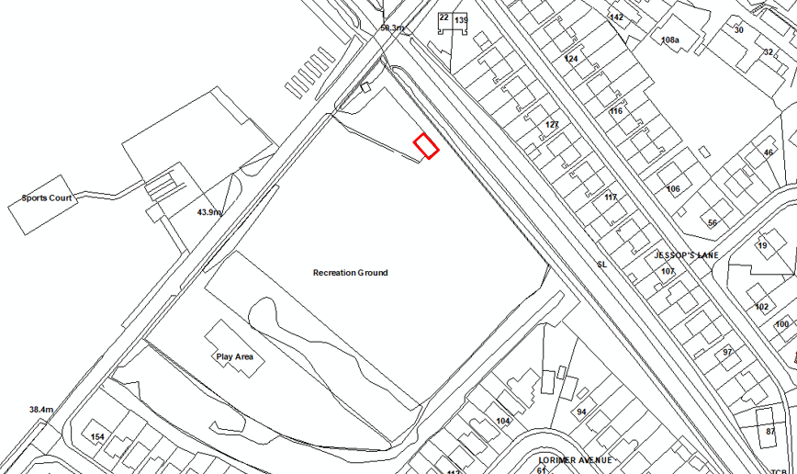

Lead Agency:
Lambley Village Cricket Club
How does the project meet a need created by new development:
CIL liable development has commenced and generated substantial CIL receipts adjacent to the Lambley Lane Recreation Ground. Approval has been granted, as part of the Chase Farm Development, for 970 dwellings and a local centre. This will increase the population of Gedling; mainly with young families who require access to sports and recreation.

This project would see an existing sporting facility redeveloped so that it is fit for purpose and can provide sport and leisure activities for new and existing residents of the borough alike.
Total cost of project:
£90,000
How much CIL Neighbourhood Funding is required:
£75,000
Is match funding available:
Match funding of £800 from Cllr Grant Funds and £2,500 from private sponsorships secured to date.
Timeframe for delivery of project:
2024-2028
How will the project be maintained once completed:
Once completed Lambley Village Cricket Club will continue to maintain the building through club funds, sponsorship and additional fundraising if required.
Assessment of project:

Whilst the nominated project is located within a ward which has contributed significant CIL Receipts from local development, namely the new housing development at Chase Farm, Gedling, it is currently unclear how the project would benefit residents outside of members of the Lambley Village Cricket Club. As such, other nominated projects may be considered to have greater public benefit when assessing which projects to award CIL Non-Parish Neighbourhood Funding.

The site is situated approx. 500m from the centre of the large housing development at Chase Farm which has generated signficiant CIL Reciepts for Non-Parish Neighbourhood funding.

The project would enable the replacement and modernisation of the existing pavilion at the Lambley Lane Recreation Ground (south). The pavilion is used by Lambley Village Cricket Club and would ensure the protection and continued use of this area of open space for sport and lesuire activities for the fututre in accordance with the objectives of the Gedling Plan specifically Community and Place.

Notwithstanding the opportunities to improve health and wellbeing within the Borough, the proposed project is still considered to be in its early infancy and, as of yet, detailed plans have not been provided. It is considered that the project may require Planning Permission and as such I would recommend that this project is held on the Local Infrastructure Schedule until it has been established if planning permission is required and if so an application has been submitted to, and determined by, the Local Planning Authority. If planning permission is obtained then a review of the suitability of CIL Non-Parish Neighbourhood Funding could be undertaken.

Recommendation: No allocation for CIL Non-Parish Neighbourhood Funding at this time. Retain on Local Infrastructure Schedule for next round of awards.

Project Reference:  LIS4 | Project Name:  MAS Community Sports Development
Project Description:
To build a community sports hub along with 4G pitches, changing rooms and a community room on Lambley lane in Gedling.

There is currently a huge lack of sports provision in Gedling. With so many new houses the desperate need for a facility has grown. MAS coaching have over 400 children on waiting lists. We currently coach over 800 children and adults each week. Our sessions are vital to the mental health of our community.

The Community Hub would be a venue offering a range of services and community-based activities. This could include toddler sessions for families, a dementia café, health and fitness offerings like Yoga/Pilates, and support sessions on a range of issues determined by the community.

Access to the sessions is likely to incur small charges, and costs would be variable depending on how the session is funded – for example for some health & well-being sessions, the CIC or a provider may be able to access funds that would subsidise attendance.

It is envisaged to have a configuration in the Hub where it is possible to have at least 2 rooms that can be rented out for functions and activities – birthday parties, meetings, and general community gatherings, such as social eating. Outside of the busier times in the evenings and weekends we would want to utilise the space during weekdays for potential Alternative School Provision.

Aside from Football being the focus for the 3G facility it is hoped the surface can be used for Netball, outdoor fitness training and perhaps touch rugby sessions. MAS would also look to partner with local primary & secondary schools to provide access to the pitch.
Location:
Lambley Lane, Gedling, Nottinghamshire, NG4 4PA
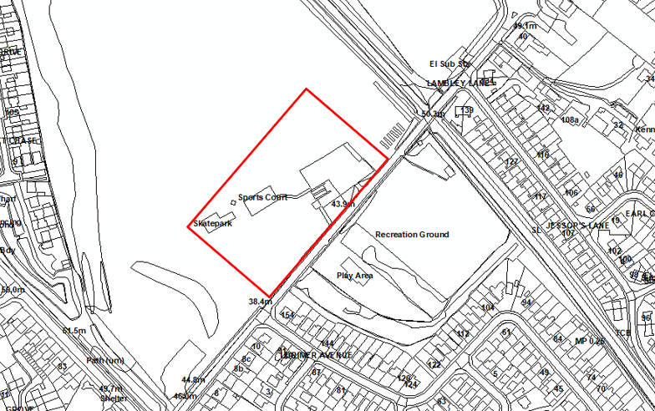

Lead Agency:
The MAS Community
How does the project meet a need created by new development:
The project will meet the health and mental-wellbeing needs of the local community. We have a petition signed of over 2000 people who are desperate for a sports facility in Gedling. Since the former Gedling school site was knocked down and a gym and two pitches lost, there has been nothing to replace these facilities. This is adding to an already huge demand for a sports facility in Gedling. We have children and adults who cannot access sport due to a lack of facilities.

The additional housing creating by the Chase Farm development immediately adjacent to Lambley Lane has further increased the need to provide more sporting facilities in the locality.
Total cost of project:
£1.8million
How much CIL Neighbourhood Funding is required:
£540,000
Is match funding available:
The Football Foundation are willing to fund 70% of the project. Other funding sources being explored include include:
- Nottinghamshire County Council (Local Communities Fund - £20,000)
- The Coalfield Regeneration Trust
- Big Lottery – Awards for All & Reaching Communities
- Cash 4 Clubs
- FCC Community Foundation – Landfill
- Sports England

Timeframe for delivery of project:
18 months
How will the project be maintained once completed:
MAS would utilise the money generated by coaching and classes to self-fund the future maintenance of the site.

In addition to coaching and classes the 3G pitches could function 3hrs per night Mon-Fri developing further potential revenue.

In addition to these revenue streams, we hope that catering on matchdays and training nights would also generate a surplus that would be used for the maintenance costs of the facilities.

A more comprehensive business case/plan will be developed with support from the Football Foundation if the project is supported.

We are confident we have both the commercial revenue generation through Mapperley All Stars Coaching and the community revenue through Mapperley All Stars Football club and wider users to make this a more than sustainable facility.

Assessment of project:

Whilst the nominated project would be compliant with Regulation 59F of the 2010 Regulations and is located in a ward which has contributed significant CIL Receipts from local development, namely the new housing development at Chase Farm, Gedling there are questions regarding the business model and commercial aspect of the project and how this would generate public benefit to local residents within the borough.

This project seeks to create a comprehensive sporting facility on Lambley Lane complete with 3G pitches and indoor sports area. The development would be situated approx. 200m from the centre of the large housing development at Chase Farm which has generated signficiant CIL Reciepts for Non-Parish Neighbourhood funding.

The proposal would create a high quality sporting facility and assosciated infrastructure to provide access to greater sports and lesuire facilities thus improving Health and Wellbeing in the community and developing a strong sense of place in accordance with the objections of the Gedling Plan.

At the present time the site has not been secured, though it is acknowledged that the applicant has stated that talks are currently ongoing with various stakeholders, furthermore, give the size and scale of the project, an application for planning permission would need to be submitted and determined by the Local Planning Authority before any decision could be made on the suitability of CIL Non-Parish Neighbourhood Funding.

It should be noted that in 2019 £40,000 of CIL Non-Parish Neighbourhood Funding was awarded to Changing Facilities at Lambley Lane Recreation Ground. This funding enabled the renovation of the community changing facilities at the Lambley Lane Recreation Group to help support the local community teams who play in this location.

Taking all of the above into consideration I would recommend that this project is not yet at a stage where Gedling Borough Council could agree to the committing of funds and as such it is recommended that the project is retained on the Local Infrastructure Schedule until further work has been progressed to address the above issues. If planning permission is obtained then a further review of the suitability of CIL Non-Parish Neighbourhood Funding could be undertaken.

Recommendation: No allocation for CIL Non-Parish Neighbourhood Funding at this time. Retain on Local Infrastructure Schedule for next round of awards.

Project Reference:  LIS5 | Project Name:  1st Gedling Scout Group HQ Refurbishment
Project Description:
1st Gedling Scout Group has over 80 local young people with different sections age 4 to 18 yrs. and is run by volunteer adults’ leaders / parents local to the Gedling area. The group is supported by an executive committee who maintain, and fund raise to keep our building, but the 1st Gedling Scouts Group lease the land it is built on. the 1st Gedling Scouts Group, the Trustees, are about to renew our lease with Southwell diocese. The Old lease was for 60 years granted by the then rector of Gedling All Hollows Church finishing in 2023. The new lease is for 30years.

As stated, the building belongs to the scout group and is in much disrepair with a leaky roof (an asbestos roof) we have been forced to replace this roof and with extra cost due to the need to employ special contractors to remove the Asbestos. Once the works to repair the roof have been complete the 1st Gedling Scouts Group will need to repair the ceiling and walls at further cost, repaint the outside walls and replace the concrete drive and play area if enough funds allow to create an undercover canopy attached to the building with open sides, so the scouts can play & train outside but undercover.
Location:
3 Willow Lane, Gedling, Nottingham, NG4 4BJ
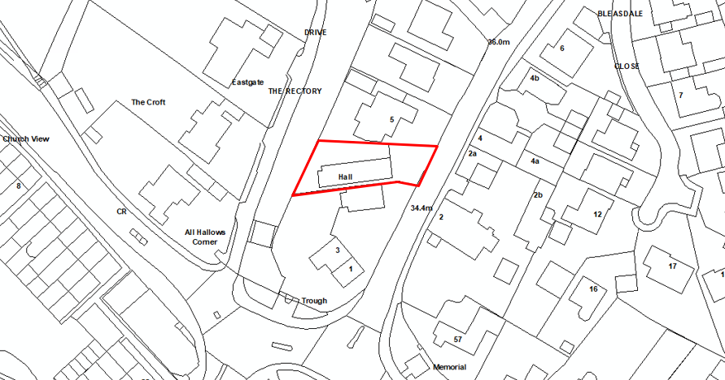

Lead Agency:
1st Gedling Scout Group
How does the project meet a need created by new development:
The Scout group supports the young people of Gedling and surrounding area. The group offers Skills for Life to young people through training and adventurous activities and is solely run by Volunteers. The Scouts Group have a long waiting list due to the surrounding new houses being built.

The project is located almost equidistance between the housing developments at Chase Farm and Land South of Burton Road, Gedling, both of which have generated significant CIL Non-Parish Neighbourhood Funding Receipts.
Total cost of project:
£76,500
How much CIL Neighbourhood Funding is required:
£60,000
Is match funding available:
Approx. £25,000 self-funded. No additional match funding secured todate.
Timeframe for delivery of project:
12-18months
How will the project be maintained once completed:
1st Gedling Scout Group are self-funded and have not at present applied for any other funding from grants or donations etc.

The membership of the group pays subs monthly that pays the electric and water bills etc, but these subs pays for outings, camps and camping equipment and badges etc for the Young People.

The hall will be maintained by the trustees once up to a standard, it has not been repaired nor painted since 2012 when a small refurb took place. 1st Gedling Scout Group do hold fundraising events to keep the hall in good and safe condition and offer the hall to other youth groups for donations to the upkeep of the building.
Assessment of project:
This nominated project is compliant with Regulation 59F of the 2010 Regulations and is located in a ward which has contributed significant CIL Receipts from local development, namely the new housing development at Chase Farm, Gedling.

The Scouts Group are a nationwide charity which provides opportunities to young people in the local area to socialise and improve health and wellbeing in accordance with the objectives of the Gedling Plan specifically Community and Place.

The project to renovate the existing facilites at the 1st Gedling Scouts Group would ensure that the Charity can continue to offer existing opportunities but also allow the group to expand their activities throughout the year through the use of improved outdoor space.

Notwithstanding the above, detailed plans have not been provided regarding the scale of the outdoor structure and the scope of the proposed works, as such it is unclear at this time whether Planning Permission would be required. I would therefore recommend that this project is held on the Local Infrastructure Schedule until it has been established if planning permission is required and if so an application has been submitted to, and determined by, the Local Planning Authority.

Recommendation: No allocation for CIL Non-Parish Neighbourhood Funding at this time. Retain on Local Infrastructure Schedule for next round of awards.

  - Having assessed each project on the Local Infrastructure Schedule it is my recommendations that the projects LIS1, LIS2, and LIS5, whilst suitable for CIL Non-Parish Neighbourhood Funding, are not yet suitably progressed to a point where is would be appropriate for Gedling Borough Council to commit to the allocation of funds. I therefore recommend that these projects are retained on the on Local Infrastructure Schedule for assessment during the next round of awards at the end of 23/24 when further progress regarding their deliverability may have been made. Projects LIS4 and LIS5 could potentially meet the requirements of Regulation 59F of the Community Infrastructure Levy Regulations 2010 (as amended), however, there are some concenrs regarding the more commericalised nature of these projects and how these would be used for the wider benefit of the general public. The CIL Officer will continue to liaise with each Lead Agency to better progress plans and better understand the projects and a re-assessment during the next consideraiton of awards in 24/25.

- Recommendations

  - Following the assessments of the submitted infrastructure projects it is my recommendation that:

- LIS1 “Cinder Path Extension (Netherfield)” No allocation for CIL Non-Parish Neighbourhood Funding at this time. Retain on Local Infrastructure Schedule.

- LIS2 “Gedling Youth & Communuty Hub Regeneration Project” No allocation for CIL Non-Parish Neighbourhood Funding at this time. Retain on Local Infrastructure Schedule.

- LIS3 “Lambley Village Cricket Club” No allocation for CIL Non-Parish Neighbourhood Funding at this time. Retain on Local Infrastructure Schedule.

- LIS4 “MAS Community Sports Development” No allocation for CIL Non-Parish Neighbourhood Funding at this time. Retain on Local Infrastructure Schedule.

- LIS5 “1st Gedling Scout Group HQ Refurbishment” No allocation for CIL Non-Parish Neighbourhood Funding at this time. Retain on Local Infrastructure Schedule for next round of awards.

  - The recommendations proposed for CIL Neighbourhood Funding will be subject to a four week public consultation. Any representations received during this consultation will be taken into account and a final recommendation as to which projects should be awarded CIL Non-Parish Neighbourhood Funding will be presented back to Cabinet in Spring 2024.

- Further Projects

  - The opportunity to submit a potential infrastructure project in the Non-Parish area of Gedling is continually open. Councillors, officers, organisations, individuals and groups can nominate infrastructure projects for funding throughout the year by visiting the Gedling Borough Council website at http://www.gedling.gov.uk/noparishcilneighbourhoodfunding/. The submitted projects will form a Local Infrastructure Schedule which will be available to view publically on the Council’s website at the same link.

  - As part of the nomination process the nominating person or group will need to supply the following information along with any other supporting information.

- Project Name | - Project Description
- Location (Plan) | - Ward
- Individual/Group submitting the nomination | - Lead Agency
- How does the project meet a need created by new development? | - Is funding through CIL required to deliver project?
- Total cost of the project? How much funding through CIL is required? | - Is match funding available?
- Timeframe for delivery of the project? | - How will the infrastructure project be maintained once completed?

- Consultation

  - A four week consultation will be held with the public, stakeholders and Ward Councillors in areas where CIL receipts are collected from chargeable developments within the non-parish area. The public consultation will commence in March 2024 to obtain views on the shortlisted projects eligible for the funding from the neighbourhood portion of CIL receipts.

  - It is proposed that the four-week consultation will be from Monday 18th March 2024 to Monday 15th April 2024.

  - The consultation will include a posting on the Keep Me Posted newsletter, the Community Initiatives page on Gedling’s Community and Voluntary E-Newsletter, an article in the Gedling Contacts magazine and direct consultation with Residential Organisation Groups throughout the borough. A link to the consultation will also be publicised on the Council’s dedicated CIL Neighbourhood Funding webpage http://www.gedling.gov.uk/noparishcilneighbourhoodfunding/ where interested parties can submit comments or representations.

  - The consultation will seek the following views:

- Do you agree with the projects identified for CIL Neighbourhood Funding in the Non-Parish Areas of Gedling? (Consider justification provided in assessments and how project meets the criteria in Regulation 59F of the CIL Regulations 2010, as amended)
- Are there any other projects on the Local Infrastructure Schedule that have been considered that you think should have been allocated funding? (Consider justification provided in assessments and how project meets the criteria in Regulation 59F of the CIL Regulations 2010, as amended)

If you can suggest any other infrastructure schemes that you consider could be included on the Infrastructure Delivery Schedule for assessment for 2022/23, please submit a nomination via http://www.gedling.gov.uk/noparishcilneighbourhoodfunding/

  - Following the consultation period all comments and representations received will be considered by Council’s officers who will prepare a final report identifying the schemes selected for funding. The report will then seek final approval from Cabinet to allocate the CIL Neighbourhood Funding awards to the relevant projects.

- Contact

  - If you require any further information regarding the CIL or Non-Parish Neighbourhood Fund please contact the CIL Officer on 0115 901 3731 or e-mail CIL@gedling.gov.uk.

